# Deploying to the 410yello site

What you’ll need:

1. A box that is either running linux or has a sftp client installed
2. Access to the code repository

# The Steps

1. Navigate to the website directory in the repo  
   EX:  
   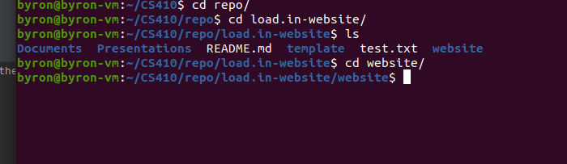
2. Log into the server with the account through sftp  
   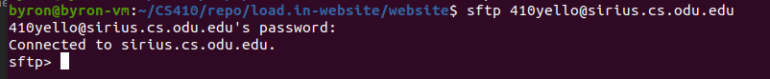
3. Navigate to the secure_html directory  
   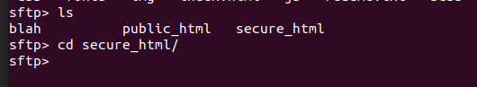
4. Run a put command with the recursive option for everything  
   
5. You should see a bunch of files going up:  
   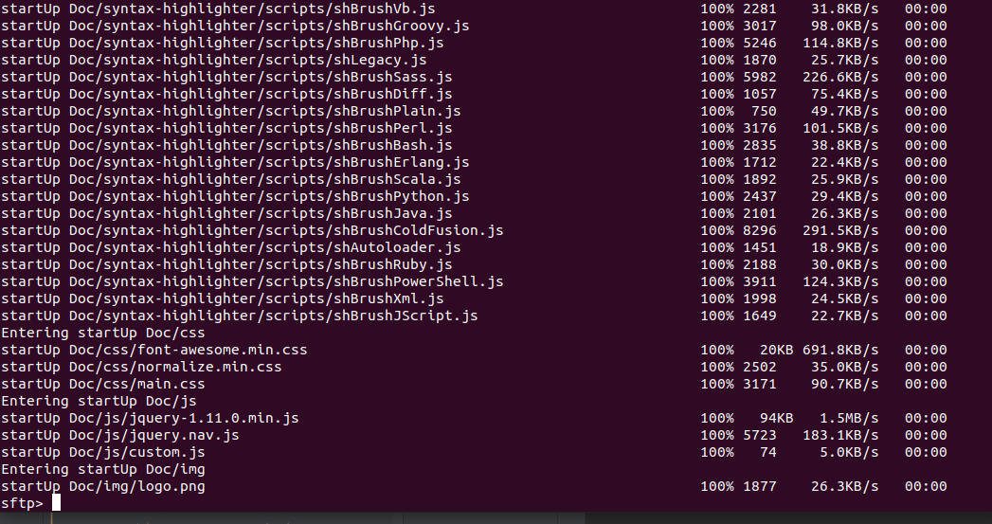
6. Celebrate (optional)